Lenna Kovalevich

Bio 471 HW #4

Due: 05/05

2. **For t=1:20**

comp <- function(t, y, p) {

N1 <- y[1]

N2 <- y[2]

with(as.list(p), {

dN1.dt <- (r1 * N1 / K1) * (K1 - N1 - a12 * N2)

dN2.dt <- (r2 * N2 / K2) * (K2 - N2 - a21 * N1)

return(list(c(dN1.dt, dN2.dt)))

})

}

t <- 1:20

y0 <- c('N1' = .1, 'N2' = .1)

p <- c('r1' = .1, 'r2' = .6, 'K1' = 2, 'K2' = 1, 'a12' = .15, 'a21' = 0.3)

sim <- ode(y = y0, times = t, func = comp, parms = p, method = 'lsoda')

sim <- as.data.frame(sim)

plot(N1 ~ time, data = sim, type = 'l', col = 'darkgreen', ylim = c(0, 2), bty = 'l')

points(N2 ~ time, data = sim, type = 'l', col = 'purple', lty = 2)

plot(N1 ~ N2, data = sim, type = 'l', ylim = c(0, 2), bty = 'l')

points(sim$N1[nrow(sim)] ~ sim$N2[nrow(sim)], pch = 21, bg = 'red', cex = 2.5)

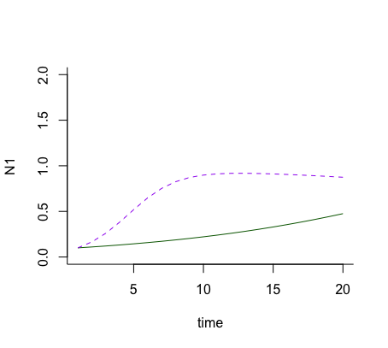 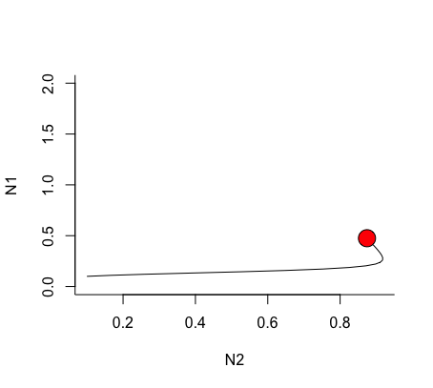

- I probably conclude that both of these species seem to exist together but N1 at a slightly greater abundance.

**For t=1:100**

comp <- function(t, y, p) {

N1 <- y[1]

N2 <- y[2]

with(as.list(p), {

dN1.dt <- (r1 * N1 / K1) * (K1 - N1 - a12 * N2)

dN2.dt <- (r2 * N2 / K2) * (K2 - N2 - a21 * N1)

return(list(c(dN1.dt, dN2.dt)))

})

}

t <- 1:100

y0 <- c('N1' = .1, 'N2' = .1)

p <- c('r1' = .1, 'r2' = .6, 'K1' = 2, 'K2' = 1, 'a12' = .15, 'a21' = 0.3)

sim <- ode(y = y0, times = t, func = comp, parms = p, method = 'lsoda')

sim <- as.data.frame(sim)

plot(N1 ~ time, data = sim, type = 'l', col = 'darkgreen', ylim = c(0, 2), bty = 'l')

points(N2 ~ time, data = sim, type = 'l', col = 'purple', lty = 2)

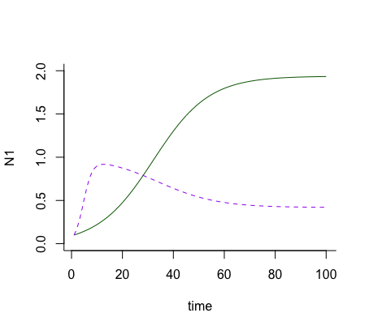 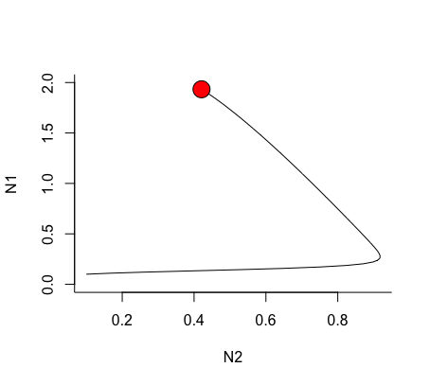

plot(N1 ~ N2, data = sim, type = 'l', ylim = c(0, 2), bty = 'l')

points(sim$N1[nrow(sim)] ~ sim$N2[nrow(sim)], pch = 21, bg = 'red', cex = 2.5)

* This data (t=100) clearly shows that there is a definite winner to competition once looking past the 20 days. It is important to interpret long term and short-term data in different ways because they will show different out comes. Short term will only give a short snip-it of what is happening and may seem conclusive but long term shows you the true data.

3. I am hoping to stick with the topic I gave about the chytrid fungus!